THE SUNDAY CONNECTION
God speaks to us in many ways, including through the Sunday Scripture readings. The Sunday Connection provides useful background and activities to better understand the upcoming Sunday's Scripture readings, helping you to connect the Scripture to daily life in a meaningful way. These passages and reflections are from the Episcopal Church website Bible Study section.

Gospel Reading
John 12:1-8

Background on the Gospel Reading
Imagine the bittersweetness of this party for Jesus. He’s spending one of his last days in his last week before his death with his dear friends Lazarus, Martha, and Mary, and the rest of Jesus’ nearest and dearest. Perhaps Mary was aware of Jesus’ emotional experience and knew on some level what her dear friend and Savior was contemplating. She fully knew Jesus’ love and power; after all, he raised her beloved brother from the dead. Mary gave a gift of prophecy and of deep love and devotion, this perfume was medicinal and used cosmetically and for burial. Perhaps Mary knew on some level that Jesus could not be contained by death, and is endlessly worthy of honor, love, and the sacrifice of humility, drying his feet with her hair as she prepares him for burial with the gift of beauty, whose scent fills the entire house. This gift was evocative and promoted strong responses from the disciples and from Jesus, who understood this gift. This was an act of mercy, beauty, and justice entwined.

HOMEWORK QUESTION FOR THE WEEK:
Mary prophetically anticipated the ministry and spread of the Gospel. How can we share the Good News of Jesus today and this week?

St. Peter’s Episcopal Church
Dartmouth, Massachusetts

April 3, 2022
Fifth Sunday of Lent

The Rev. Scott A. Ciosek
Pastor, St. Peter’s Episcopal Church
Executive Director, The Bridge: A Center for Hope and Healing
Chaplain, University of Massachusetts-Dartmouth

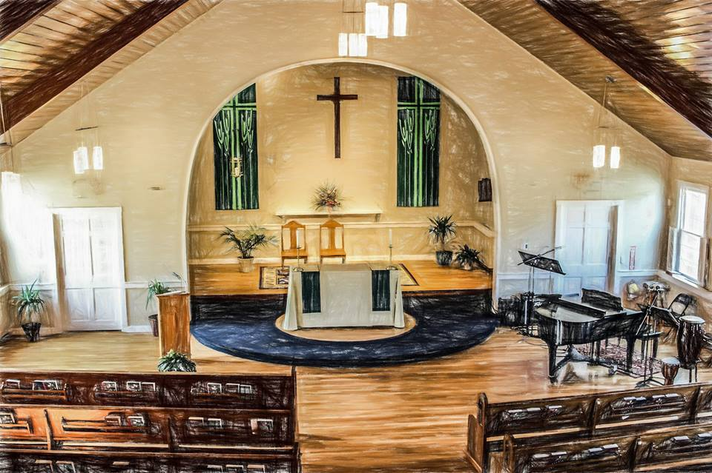

LITURGY OF THE EUCHARIST
Sunday at 10:30AM

CONTACT US
Mailing Address: 351 Elm St., Dartmouth, MA 02748
Parish Office Phone: 774.510.5661 FAX: 774.202.6940
Parish Email: stpetersdartmouth@gmail.com
Website: www.stpetersdartmouth.org

PARISH STAFF & CONTACT INFORMATION
CLERGY
The Rev. Scott A. Ciosek
Rector, St. Peter’s Episcopal Church, Dartmouth
Executive Director, The Bridge: A Center for Hope and Healing
Chaplain, University of Massachusetts Dartmouth

PARISH CONTACT INFORMATION
St. Peter’s Episcopal Church
Mailing Address: 351 Elm Street, Dartmouth, MA 02748
Office Phone: 774.510.5661
Email: stpetersdartmouth@gmail.com
Website: stpetersdartmouth.org
Live Stream: stpetersdartmouth.org/watch
Social Media: Find us on Facebook and Instagram

UMASS DARTMOUTH CAMPUS MINISTRY
Center for Religious and Spiritual Life
Rev. Scott A. Ciosek, Episcopal Chaplain
McLean Campus Center, Second Floor, Office 220
508.999.8000 / sciosek@umassd.edu

THE BRIDGE: A CENTER FOR HOPE AND HEALING (Counseling Center)
Mailing Address: 351 Elm Street, Dartmouth, MA 02748
Office Phone: 508.997.0903
Email: thebridgeadartmouth@gmail.com
Website: thebridgedartmouth.org

PARISH LEADERSHIP TEAM (VESTRY)
Wardens Susan Sousa and Michelle Woodacre
Clerk Barbara Bosworth
Treasurer Molly Armando
Members Elizabeth Carbone, Martin Costa, Tanya Gouveia, Michaela Mello, Jeffrey Soares

PARISH STAFF / MINISTRY LEADERS
Director of Liturgical Music Michael Moniz
Director of Youth & Family Ministry TBA
Baptism Preparation Team Coordinator Isabel Consoli
Administrative Assistant / Part-time (St. Peter’s) Kathy Thomas
Financial Administrator (St. Peter’s & The Bridge) Michelle Letts
Director of Parish Outreach Ministry Barbara Bosworth
Building & Facilities / Sexton TBA
Building Rental/Use Supervisor Martin Costa
Building & Grounds Committee Coordinator Martin Costa
Pastoral Care for Homebound and Sick Liz Carbone, Nancy Rolli, Susan Riley
LGBTQ Ministry Jenn Oliveira
Concert Coordinator Barbara Bosworth
Multicultural Ministry Brittany Jenney
Altar Guild Coordinator Jenn Oliveira
Keyboard Accompanist Ann Lamoureau
Drummer Kenny DeAlmeida
Guitar Christine Homen

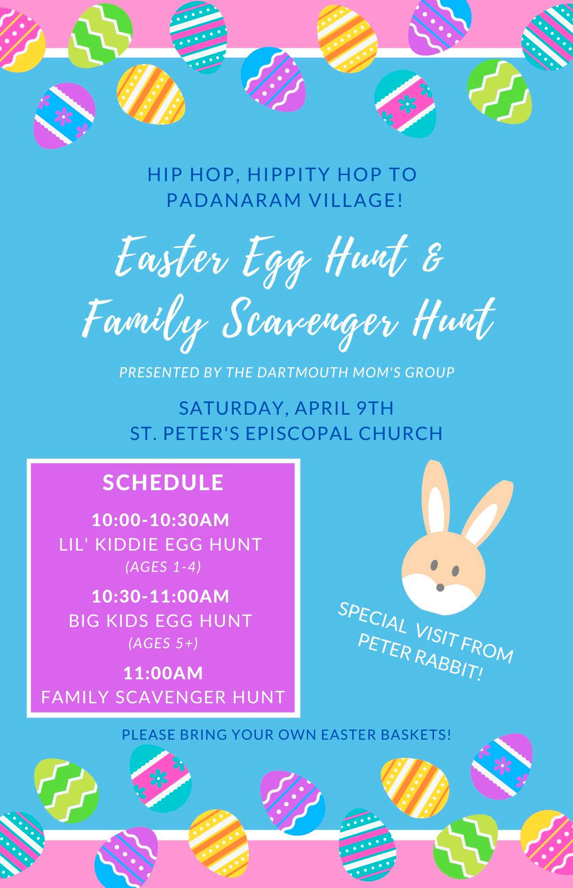
St. Peter’s Episcopal Church
351 Elm Street
Dartmouth, MA 02748
website: www.stpetersdartmouth.org
email: stpetersdartmouth@gmail.com
774.510.5661

EASTER FLOWERS 2022
Your Name: __________________________________________________________________________
Address: __________________________________________________________________________
Phone: __________________________________________________________________________
Email: __________________________________________________________________________
If you choose to make your donation in memory of a loved one who has died (optional) please write their name(s) below. Please PRINT CLEARLY.
________________________________________________________________________________________________________________________________________________________________________________________________________________________________________________________________________________________________________________________________________________________________________________
Amount donated: $________________________
Please make check payable to St. Peter’s Episcopal Church and please write EASTER FLOWERS on notation line. Thank you for your generosity.
Please put this form and your check in an envelope and put in collection basket at Mass OR mail to:
St. Peter’s Episcopal Church
Attn: Easter Flowers
351 Elm Street
Dartmouth, MA 02748

DEADLINE: SUNDAY, APRIL 3, 2022
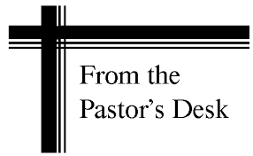
Dear Friends and Parishioners:
Welcome to our liturgy this weekend! We invite you to join us next Saturday, April 9 for our first ever Easter Egg Hunt and Scavenger Hunt coordinated by Molly Armando and her team. It will be sponsored by the Mom’s Group! Please see the flyer elsewhere in the bulletin!
Today, we welcome, install and pray for our NEW Leadership Team (vestry) during our 10:00AM Liturgy of Holy Eucharist.
We are grateful for the new energy and much-needed sense of renewal that this new Leadership Team brings to lead us and guide us, all the while open to the Spirit, in this post-pandemic world. We are always about strengthening our vision and sense of mission! Very exciting times lie ahead for us especially as we prepare to welcome our new Director of Youth & Family Ministry, a new staff position at St. Peter’s.
Our new Leadership Team consists of:
Wardens Susan Sousa and Michelle Woodacre (final term)
Clerk Barbara Bosworth
Treasurer Molly Armando
Members Elizabeth Carbone, Martin Costa, Tanya Gouveia, Michaela Mello,
Jeffrey Soares

We also invite you to see, elsewhere in this bulletin, our 2022 Palm Sunday, Holy Week and Easter schedule. We have not celebrated Holy Week and Easter in-person for 2 years due to the pandemic! We hope this year will make up for that and we hope to put so much energy into creating beautiful liturgies for Holy Week.

We hope you can join us for these beautiful celebrations. Holy Week is about journey with Jesus and one another as we commemorate these sacred events in this life. These are the three most sacred days on our liturgical calendar because they tell the story of salvation. So many people, in recent years, have come to experience the beauty of these days. I hope that even more people will celebrate these days with us this year so that we fully enter into the beauty of Holy Week.

We invite you to pray with us during Holy Week. Maundy Thursday is the Mass of the Lord's Supper. The Good Friday Liturgy is the reading of the Lord's Passion and then the Liturgy of the Resurrection of the Lord on Easter Sunday morning. We can never go from Palm Sunday right into Easter without living the sacred days in between as we walk from the Cenacle and Upper Room; to the Cross, and then to the empty tomb. May this Holy Week be a time of grace and spiritual depth for you this year. Our lives are always about death and resurrection. No matter what we go through in life, we are meant to rise!

Blessings in the coming week!

Peace,
(Rev.) Scott A. Ciosek, Rector

EPISCOAPAL CAMPUS MINISTRY @ UMASS D
The Center for Religious and Spiritual Life
University of Massachusetts Dartmouth
285 Old Westport Road, Dartmouth, MA 02747
Office Phone: 774.510.5661 x101
Rev. Scott A. Ciosek, Episcopal Chaplain
McLean Campus Center, Office 202
Email: sciosek@umassd.edu

NEED TO TALK?
There’s a lot going on in our world:
War in Ukraine, Covid-19, oppression, injustice, bigotry, racism.

There is a different way… THE WAY OF LOVE

How do we hold onto LOVE & HOPE in troubling times?

Dr. Martin Luther King often said we have two choices:
chaos or community.

CAMPUS MINISTRY invites everyone (students, faculty and staff)
to be part of this CONVERSATION…
- To talk about what we are feeling, and what fills our hearts
- To recommit to the power of LOVE on campus and in the world

TWO SESSIONS:
Wednesday, April 6, 2022 from 12:00-1:00P (University Club, Campus Center)
Tuesday, April 12, 2022 from 12:00-1:00P (University Club, Campus Center)

SMILE FUNDRAISER
Our parishioner, Tracey Oliver, is coordinating a SMILE FUNDRAISER offered by Oh! Photography to help support our adopted Afghan Family. A "photo studio" will be set up in the Community Room and Tracey Oliver will capture the smiling faces of St Peter's parishioners in their Sunday best after the Easter Sunday Service of Holy Eucharist on April 17, 2022. You will receive 4 edited digital images by email. So, let's all smile, say cheese and have some fun while raising money for a worthy cause! More information will follow.

PROTECTION OF CHILDREN AND MINORS
All individuals 17 or over, who will or who may have access to children, MUST complete a CORI form prior to working or volunteering in the parish. Because the Episcopal Church (and St. Peter’s) stands for the protection of children, teens and their families, we require a CORI check to be performed annually for the following people:
-All paid parish employees
-All vestry members
-Any parish volunteers (all organizations, committees, etc.)
-Anyone working with children ministries.
SMALL GROUPS @ SPEC
Small Groups at St. Peter’s Episcopal Church help keep people connected and to allow people the opportunity to grow in their spiritual lives. Small Groups are made up of 6-12 parishioners who come together (online on now in-person) to share faith, to go deeper in the weekly message, and to support one another in their relationship with Christ. Small Groups help to build community and bring people closer together in fellowship. Small Groups invite us to focus on Scripture, to pray, reflect, and discuss how the Word of God is relevant today in our daily lives. It is our HOPE in the future that every parishioner will be part of a Small Group. If you are interested in being part of a SMALL GROUP at St. Peter’s, please email stpetersdartmouth@gmail.com with your contact information.

IMPORTANT: ”GETTING TO KNOW YOU” FORMS
Friends, if you do not receive weekly emails from our parish, that means you are most likely not a registered parishioner. It may also suggest that you have never filled out a “Getting to Know You” Form. These yellow forms are located on the Welcome Table. Please fill one out, if you haven’t, so you can receive communications from the parish.

FINANCIAL REPORT FEBRUARY 2022
Thank you for your generosity to our Parish Family. We invite you to review our Monthly Financial Statement so that you can get a “snapshot” of what our monthly expenses are. As St. Peter’s continues to grow in numbers and activity, so do our expenses. Some expenses, such as the (very expensive) Toshiba copier and all copy costs including our weekly Worship Aid and Weekly Bulletin are absorbed by our counseling center, The Bridge: A Center for Hope and Healing. Snow plowing is also a split cost.
As you can see our INCOME is slightly less than our expenses. In the next few months, we are hoping to welcome a Director of Youth & Family Ministry on board. While we hope to fill this gap with grants and increasing our fundraising efforts, we also rely on your faithful support of our parish. If you have not yet filled out a 2022 Stewardship Pledge Form, let us know how you can help! They are available on the Welcome Table after Mass. Thank you for your generosity.

INCOME
Collection (Budget, mail-ins & loose plate collections at Mass) 5,842.00
Collection (Youth Ministry) 500.00
Collection (Afghan Family Ministry to support local family) 2,490.00
Collection (Mom’s Group Fundraising for Mom’s Group use) 500.00
Interest Income 2.21
Rental Income (Former Parish Rectory Rental) 1,800.00
________________________________________________________________________________
TOTAL INCOME 11,134.21

EXPENSES
UMass Campus Ministry (Grant money from Diocese – not parish money) 2,124.48
Music Equipment 327.00
Live Stream Hosting Cost 75.00
Altar Supplies 142.73
Liturgical Musicians 2,121.56
¼ Clergy Compensation **see notation on next lines! 2,181.57
(25% of overall clergy compensation is paid by St. Peter’s; the remaining 75% of Clergy Compensation is paid through the parish 501c3 Counseling Center, The Bridge: A Center for Hope and Healing and the UMass Dartmouth chaplaincy grant. This amount includes clergy health insurance costs)
Clergy Pension 479.67
Electric (Main Buildings) 343.62
Electric (Carriage House) 40.99
Gas (Main Buildings) 1,093.17
Maintenance on Former Rectory 265.61
Snow Plowing 362.50
Maintenance Supplies 159.32
Financial Administrator Compensation 580.00
Mom’s Group Fundraising Expenses 869.27
Postage 58.00
Realm (Parish Database Software) 34.00
Office Supplies (W. B. Mason) 1,894.72
Telephone/Internet 462.90
Vanco Credit Card Charges (Online Pledging System) 77.54
__________________________________________________________________________________
TOTAL EXPENSES 13,693.65

SAVE THE DATES FOR OUR
HOLY WEEK / EASTER TRIDUUM

The word “triduum” means “three days.” These are the three most sacred days on our liturgical calendar because they tell the story of salvation. So many people, in recent years, have come to experience the beauty of these days. I hope that even more people will celebrate these days with us this year so that we fully enter into the beauty of Holy Week.

The summit of the Liturgical Year is the Easter Triduum—from the evening of Holy Thursday to the evening of Easter Sunday. Though chronologically three days, they are liturgically one big day unfolding for us the unity of Christ's Paschal Mystery.

The celebration of the Triduum marks the end of the Lenten season. Lent ends with the beginning of our Maundy Thursday liturgy. The liturgical services that take place during the Triduum are:
The Mass of the Lord's Supper, Good Friday of the Lord's Passion and the Liturgy of the Resurrection of the Lord on Easter Sunday morning.

PALM SUNDAY: April 10, 2022
10:00AM: Liturgy of Palms and Holy Eucharist

MAUNDY THURSDAY: April 14, 2022
7:00PM: The Mass of the Lord’s Supper and Washing of Hands
(As an additional safety measure, individual towels will be given to those who wish to participate in the Washing of Hands.)

GOOD FRIDAY: April 15, 2022
7:00PM: Good Friday of the Lord’s Passion
(Communion from the Reserved Sacrament)

EASTER SUNDAY: April 17, 2022
10:00AM: Festival Holy Eucharist (with organ, piano, brass)
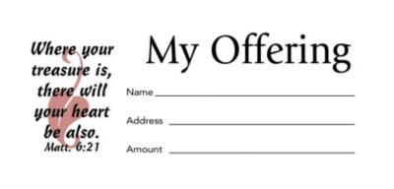
THE IMPORTANCE OF USING CHURCH BUDGET ENVELOPES

Whether you participate in Online Giving, mail your check in, or place your donation in the collection basket at Mass, we ask everyone to please use Parish Budget Envelopes on a weekly basis.

WHY?

1. It helps the parish keep track of your pledge and donations. If you place loose money in the collection basket, it is not recorded as your donation. This helps the parish to provide you with a yearly statement of your contributions at the end of the year if you request one for tax purposes.

2. IF YOU MAKE YOUR CONTRIBUTION USING CASH OR CHECK: Simply place your donation in the Parish Budget Envelope for that given Sunday and put it in the collection basket during Mass.

3. IF YOU PARTICIPATE IN ONLINE GIVING: We still ask you to take a box of Parish Budget Envelopes. Many people who use Online Giving have said they feel strange about not having anything to put in the collection plate during Mass and they feel awkward as the basket passes by. To enable everyone to participate in the parish offertory at Mass, we ask those who give ONLINE to also bring your empty envelope each week and still put it in the collection basket. On the front of the envelope, please check the box with the option “I GIVE ONLINE.” Then simply place it in the collection basket during Mass. With more and more people participating on Online Giving, this will encourage everyone to be able to put something in the collection basket.

4. There is a dated budget envelope for each Sunday of the liturgical year and special days during the year such as Holy Week. The envelopes in the box are in chronological order by date. When you pick up your box of envelopes, you will be assigned a number that will be entered into the parish database system.

5. Your cooperation will help us achieve greater financial organization of the parish.
For the next 3-4 Sundays, following our Service of Holy Eucharist, two parishioners will be near the Welcome Table with boxes of envelopes. We ask you to please take a box and we will record the number to enter into our parish database.

THANK YOU AGAIN FOR YOUR GENEROUS SUPPORT OF OUR PARISH FAMILY!

An Invitation from Presiding Bishop Michael B. Curry to Practice the Way of Love

I pray that you, being rooted and established in love, may have power, together with all the Lord’s holy people, to grasp how wide and long and high and deep is the love of Christ, and to know this love that surpasses knowledge—that you may be filled to the measure of all the fullness of God. — Ephesians 3:17-19

In the first century Jesus of Nazareth inspired a movement.A community of people whose lives were centered on Jesus Christ and committed to living the way of God’s unconditional, unselfish, sacrificial, and redemptive love. Before they were called “church” or “Christian,” this Jesus Movement was simply called “the way.” Today I believe our vocation is to live as the Episcopal branch of the Jesus Movement. But how can we together grow more deeply with Jesus Christ at the center of our
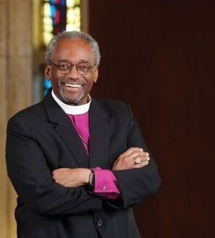
lives, so we can bear witness to his way of love in and for the world? The deep roots of our Christian tradition may offer just such a path. For centuries, monastic communities have shaped their lives around rhythms and disciplines for following Jesus together. Such a pattern is known as a “Rule of Life.” The framework you now hold The Way of Love: Practices for Jesus-Centered Life — outlines a Rule for the Episcopal branch of the Jesus Movement.
It is designed to be spare and spacious, so that individuals, ministry groups, congregations, and networks can flesh it out in unique ways and build a church-wide treasure trove of stories and resources. There is o specific order you need to follow. If you already keep a Rule or spiritual disciplines, you might reflect and discover how that path intersects with this one. By entering into reflection, discernment and commitment around the practices of Turn – Learn – Pray – Worship – Bless – Go – Rest,
I pray we will grow as communities following the loving, liberating, life-giving way of Jesus. His way has the power to change each of our lives and to change this world.
Your brother in the Way of Jesus,

The Most Reverend Michael B. Curry,
Primate and Presiding Bishop of the Episcopal Church

WHAT DO YOU SEEK?
Early in his ministry, Jesus of Nazareth was surrounded by crowds. He turned and asked, “What do you seek?” (John 1:38). For more than a thousand
years, monastics have greeted pilgrims knocking on their doors by asking: “What do you seek?” Today, each of us can pause with the same question.
As much as the world has changed, the fundamental human hopes and yearnings that draw us to faith may not be so different. For so many …

WE SEEK LOVE
To know God’s love, to love and be loved by others, and to love ourselves

WE SEEK FREEDOM
From the many forces —
sin, fear, oppression, and division that pull us from living as God created us to be:
dignified, whole, and free.

WE SEEK ABUNDANT LIFE
Overflowing with joy, peace, generosity, and delight. Where there is enough for all because we all share with abandon.
A life of meaning, given back to God and lived for others.

WE SEEK JESUS
The way of Jesus is the Way of Love, and that way has the power to change lives and change the world.

THEN COME AND FOLLOW...

